**1.1 A primer in machine learning**

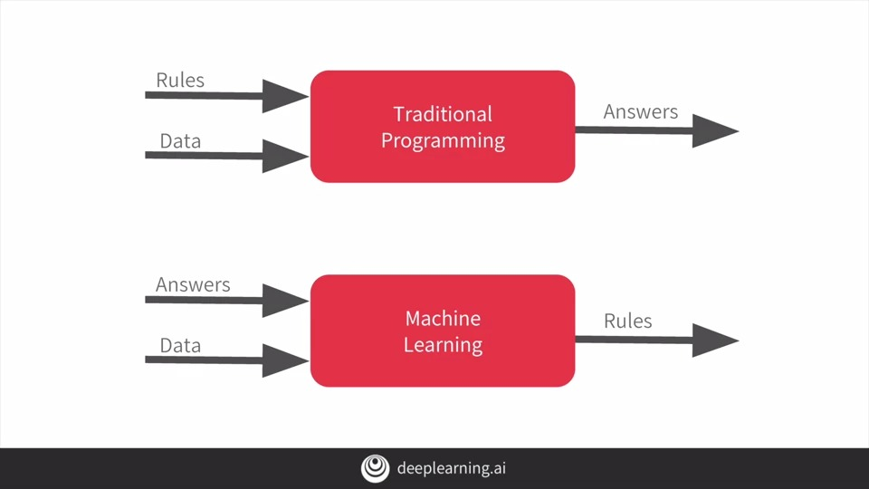

**1.2 The ‘Hello World’ of neural networks**

Keras makes it really easy to define neural networks.

A neural network is basically a set of functions which can learn patterns.

The simplest possible neural network is one that has only one neuron in it, and that's what this line of code does.

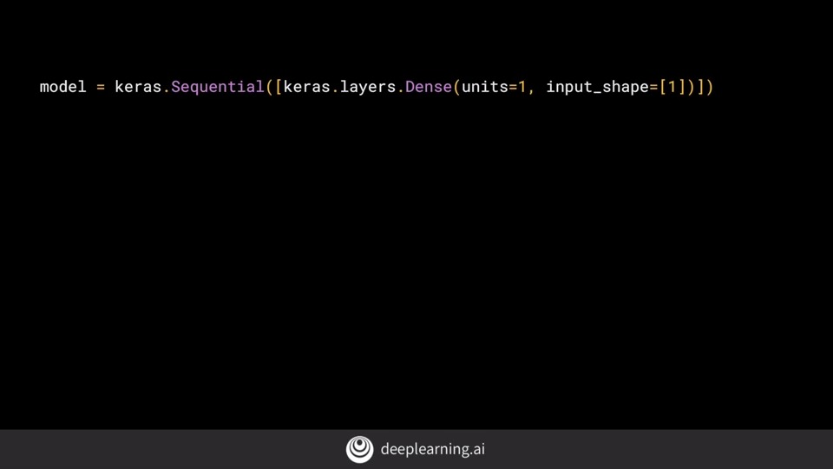

In keras, you use the word **dense** to define a layer of connected neurons.

There are two function roles that you should be aware of though and these are loss functions and optimizers.

In this case, the loss is **mean squared error** and the optimizer is SGD which stands for **stochastic gradient descent**.

1.3 **Working through ‘Hello World’ in TensorFlow and Python**